

**Shale-PIZZAAsss**

|  |  |  |
| --- | --- | --- |
| **Supervisor:** | *LÊ THANH NHÂN* | |
| **Semester:** | *1* | |
| **Batch No:** | *T1.2004.M1* | |
| **Group No:** | *3* | |
| **Order:** | **Full name** | **Roll No.** |
| *1.* | *PHUNG THE VIET* | *Student1262873* |
| *2.* | *NGUYEN VAN MINH* | *Student1262861* |
| *3.* | *NGUYEN CONG DANH* | *Student1256056* |

***Month****: 07* ***Year****: 2020*



This is to certify that

|  |  |
| --- | --- |
| **Mr.** | **PHUNG THE VIET** |
| **Mr.** | **NGUYEN VAN MINH** |
| **Ms.** | **NGUYEN CONG DANH** |

Have successfully Designed & Developed

|  |  |  |
| --- | --- | --- |
|  |  |  |
| **Shale-PIZZAAsss** | | |

Submitted by:

|  |
| --- |
| **Mr. LE THANH NHAN** |

Date of Issue:

|  |  |
| --- | --- |
|  |  |

Authorized Signature:

|  |  |
| --- | --- |
|  |  |

**Project Acknowledge**

eProject is a step-by-step learning environment that closely simulates the classroom and Lab based learning environment into actual implementation. It is a project implementation at your fingertips!! An electronic, live juncture on the machine that allows you to

+ Practice step by step i.e. laddered approach.

+ Build a larger more robust application.

+ Usage of certain utilities in applications designed by user.

+ Single program to unified code leading to a complete application.

+ Learn implementation of concepts in a phased manner.

+ Enhance skills and add value.

+ Work on real life projects.

+ Give a real life scenario and help to create applications more complicated and useful.

+ Mentoring through email support.

**Objectives of the project**

The Objective of this program is to give a sample project to work on real life projects. These applications help you build a larger more robust application.

The objective is not to teach you JavaScript/Dreamweaver but to provide you with a real life scenario and help you create basic applications using the tools.

You can revise the chapters before you start with the project.

This project is meant for students who have completed the module of HTML5. These programs should be done in the Lab sessions with assistance of the faculty if required.

It is very essential that a student has a clear understanding of the subject. Students should go through the project and solve the assignments as per requirements given.

Kindly get back @ [eprojects@aptech.ac.in](mailto:eprojects@aptech.ac.in) in case of any doubts regarding the application or its objectives.

**Synposis**

Shale-PIZZAAsss is famous for Pizzas, Pasta food. Shale-PIZZAAsss was opened with one restaurant in the year 1960 and now it has more than 1000 restaurant across the countries. A website needs to be designed must display the menus, Contact Us (so as to call a make order). Details of various franchise, locations, feedback must be included.

The website is to be developed for the Windows Platform using HTML5, JavaScript and Geolocation. The site should work well in all leading browsers including Chrome, IE, Firefox etc.

**Problem Definition**

Shale-PIZZAAsss is famous for pizza, Pasta food. Shale-PIZZAAsss was opened with a restaurant in 1960 and now it has more than 1000 restaurants across the country. They need a website for customers to place orders and partners to contact.

Request:

+ Display menu

+ Contact us (to order).

+ Details about different franchises.

+ Location.

+ Feedback must be included.

**Functional Descriptions**

The website will be created based on the following model.

1) Home Page must display the image section of the website.

2) Links such as

- Home

- Menu

i. Pizza

ii. Garlic Breads

iii. Pizza Sandwiches

iv. Desserts

v. Beverages

- Menu Download

- Store Location

- Locations

- Feedback

- Franchise Info

3) Other Additional Links such as

- Weekend Special

- Combo offers

- Gallery

4) There is a link to the store location.(eg. GoogleMaps) and the email address which when clicked will invoke the local mail client from where they can send an email.

**User**

- Access and refer to product information on the website.

- Participate in shopping events of the website.

- Contribute ideas, feedback or suggestions to the store.

**Webmaster**

- The website has all the necessary information.

- Change the content, images and layout of the website.

**Customer Requirement Specifications**

**Client: Shale-PIZZAAsss**

Business/Project Objective: Renovate the look and feel of the website Shale-PIZZAAsss which should be more catchy and helpful for the business perspective.

**System input:**

- Information about pizzas.

- A store location listing

- Franchise principle

- Contact details for users to keep in touch with Shale-PIZZAAsss.

**Output from the system:**

- Display of products that users are looking for, including photos, prices and descriptions.

- Display store location

- Franchise

**From web users:**

- Feedback

- Contact us

**Hardware / software requirement**

**User:**

- PC: from Pentium 166 or upper

- RAM: from 64 Megabites or upper

**Webmaster:**

- Notepad/HTML editor

- Dreamweaver

- IE 5.0/ Netscape 6.0/Chrome

**Device**

Windows Platform

**Server**

**Client**

**HTML**

**CSS**

**Javascript**

**JQuery**

**Boostrap**

**AngularJS**

PIZZA

MENU

GARLIC BREADS

SANDWICHES

MENU DOWNLOAD

DESSERTS

BEVERAGES

STORE LOACATION

HOME

LOACAION

CONTACT US

FEEDBACK

FRANCHISE INFO

EVEN

WEEKEND SPECIAL

COMBO OFFERS

**Overview:**

- Before you begin, please make sure that you have a working internet connection.

- Click on z1Home.html locate inside the folder Source file to get start.

**I. Home**

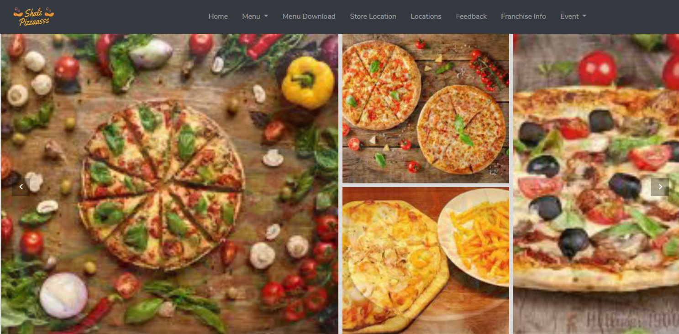

This section contain some instruction on how to navigate the website:

1. **Logo:**

- The logo and website name lie on the top left corner of the page.

- Click on the logo to go to the homepage.

1. **Navigation bar:**

- The navigation bar contains information about all the main pages of the site, located above and in the middle of the site.

- To go to a specific page, click the Page Name in the navigation bar:

+ To go to home page, please click on **HOME** or logo website.

+ To navigate to the product, please click **MENU** or select directly on a product in **HOME**.

+ To view the menu, please click **MENU DOWNLOAD**.

+ To view store location, please click **STORE LOCATION**.

+ To view the location and contact us, please click on **LOCATION**.

+ To view franchise information, please click **FRANCHISE INFO**.

+ To view the store's promotions and events, please click **EVENT**.

1. **Product introduction**

- Gallery Slide, we can use for promotion’s banner or some highlighted activities that the.

- Information on new and best-seller products on the store.

1. **New product**

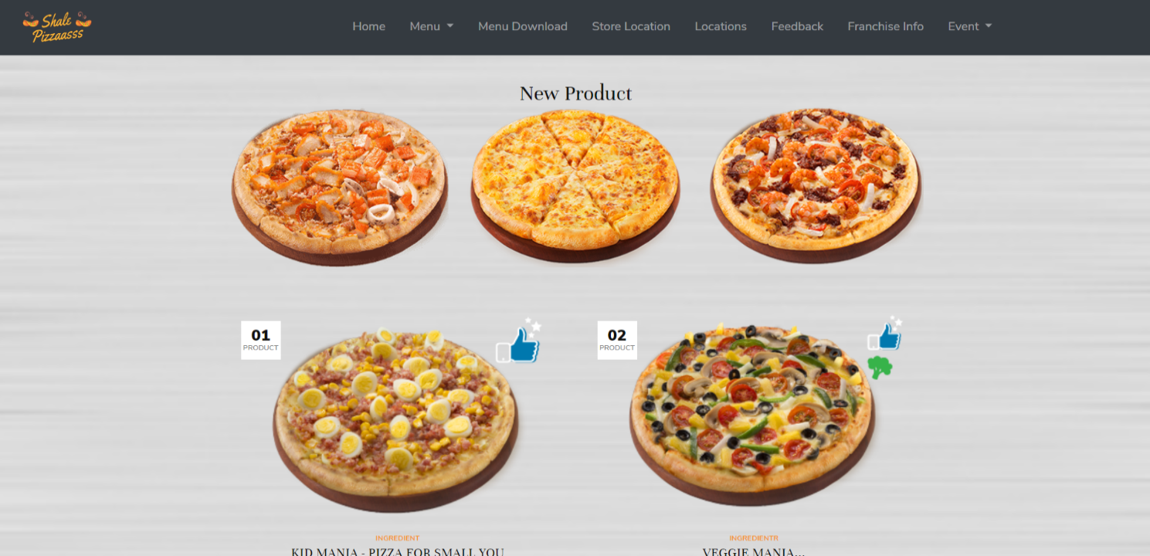

- Contains photos and highlights information of some of the store's new products.

- When clicking on the picture or product name will move to MENU page

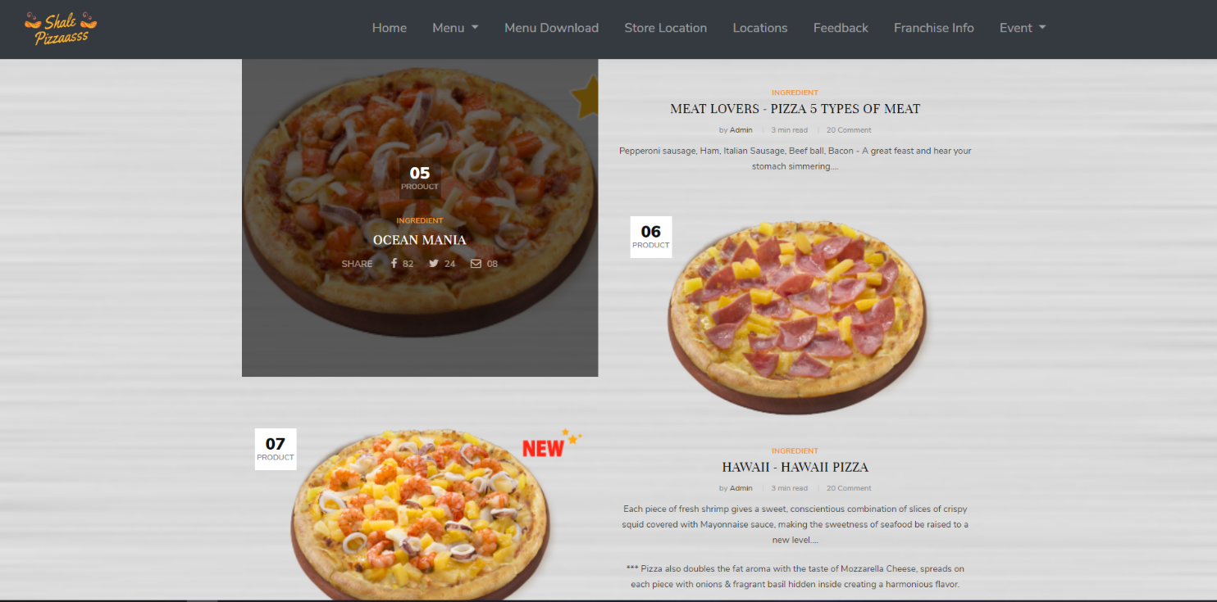

1. **Subscribe**

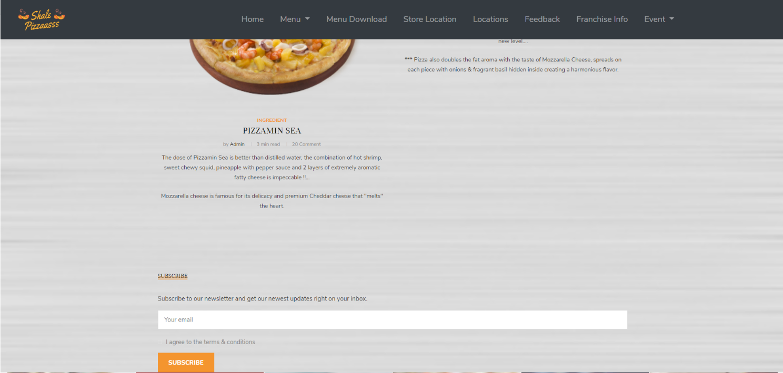

- To keep track of store events customers can leave an Email to receive notifications from the store.

- Email must be valid ([#@#.com](mailto:#@))

**Description:**

This page gives customers more information about new products and some of the store's offers.

**II. Menu**

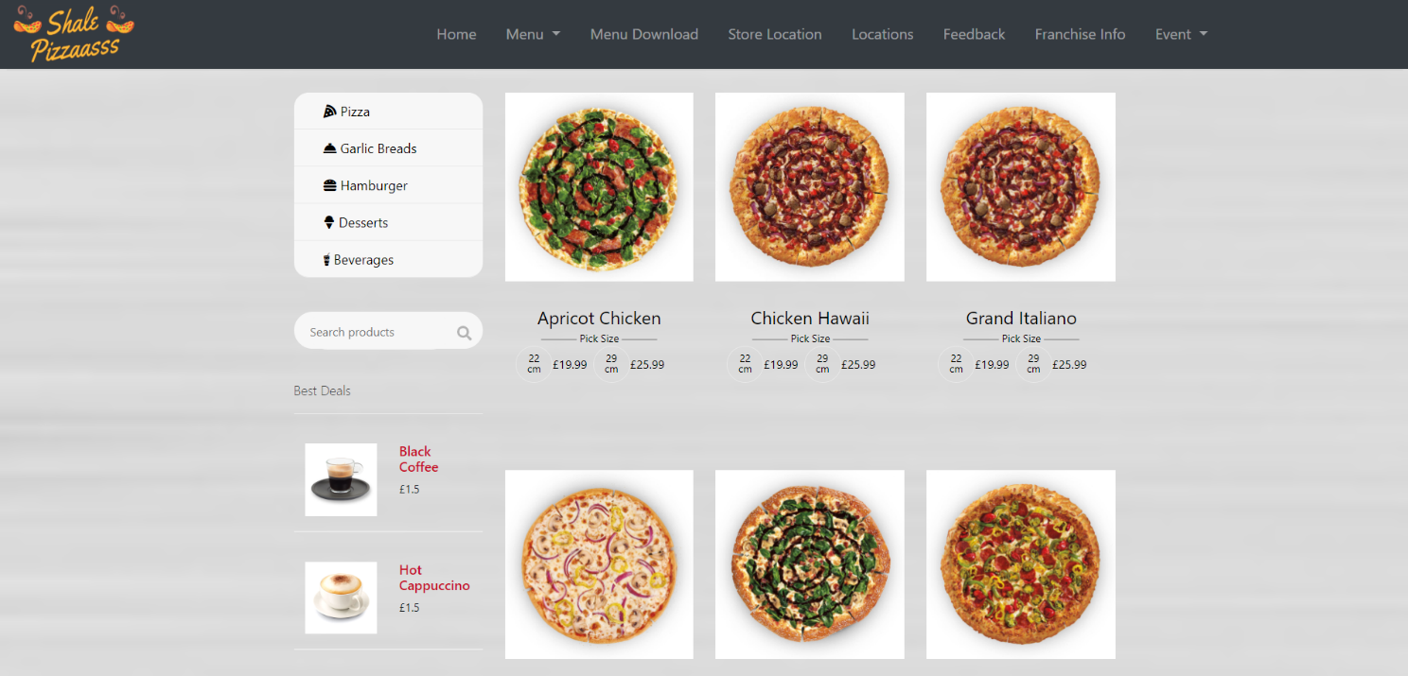

This section contains all of the site's products:

1. **Navigation menu**

- Located above and to the left of the screen.

- The navigation bar contains information about all products of the website, such as:

+ To view all types of Pizzas, please click **PIZZA**.

+ To view all types of Garlic bread, please click **GARLIC** **BREAD**.

+ To view all types of Hamburgers, please click **HAMBURGERS**.

+ To view all types of Dessert, please click **DESSERT**.

+ To view all types of Beverages, please click **BEVERAGES**.

1. **Search product**

- To search for a product, please enter the product name in **SEARCH** **PRODUCT**.

**Description:**

This page helps customers choose the product they need via the navigation menu.

**III. STORE LOCATION**

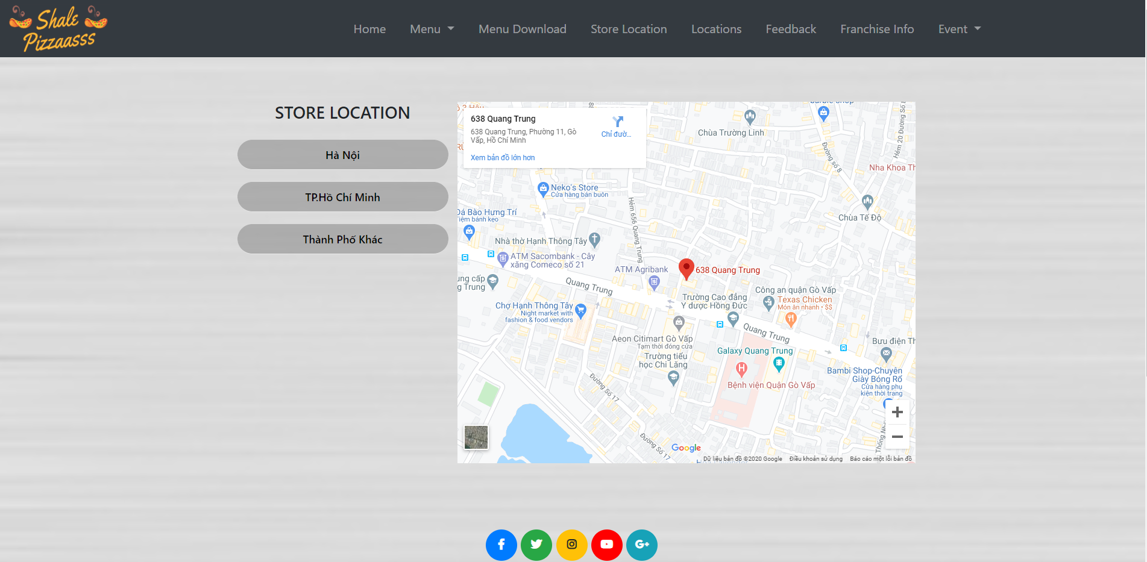

Hình 1

This section contains the locations of stores located in each area:

**Store Location**

- To find the location of the store in any area, please click the Region Name in Figure 1. When you click it will look like Figure 2.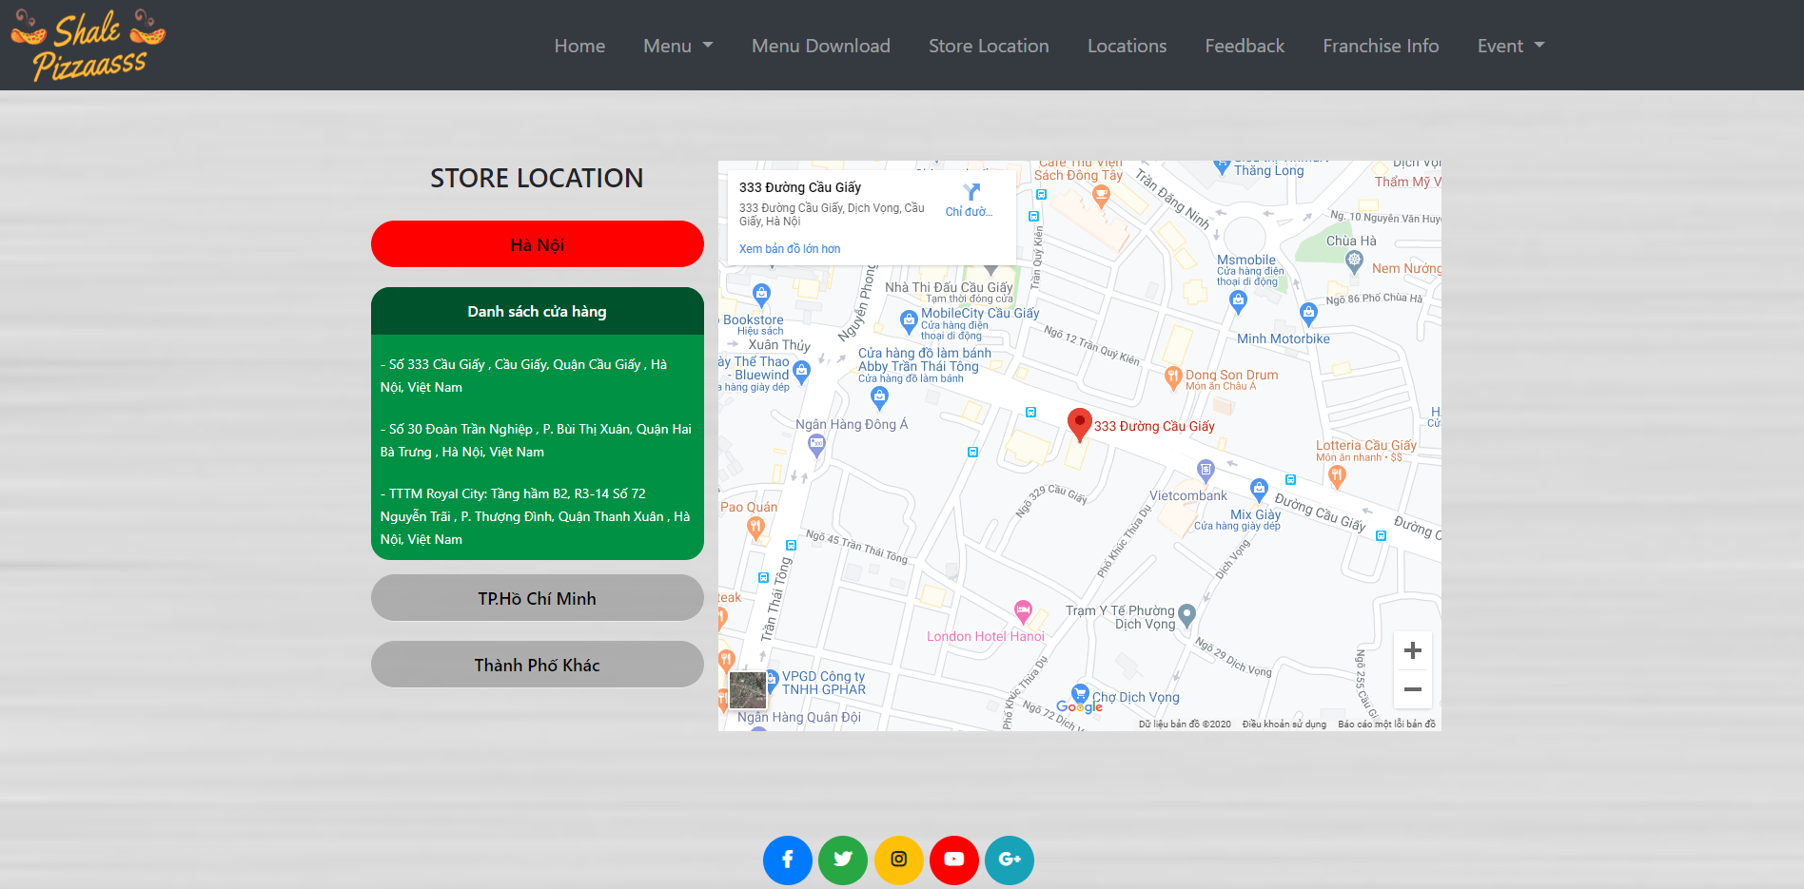

Hình 2

**IV. FEEDBACK**

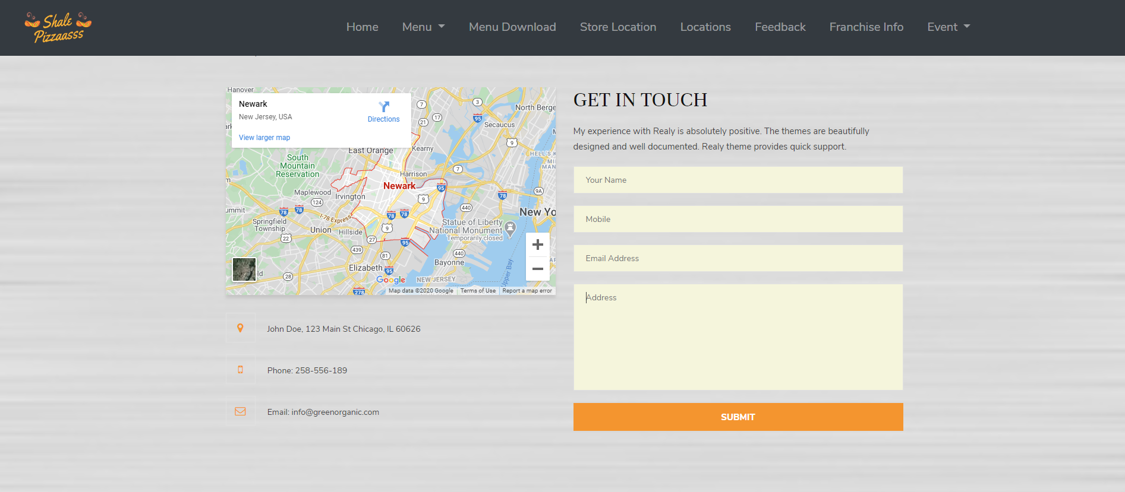

1. **Map**

- Locate the map of regional franchisees.

1. **Get in touch**

- Your name( Requests must be letters and limited to [6-20] characters.)

- Mobile( Required is a digit, limited number [10] digits).

- Email Address( Requires the correct syntax [#@#.com]).

- Feedback content.

**Description:**

This site gives customers a place to leave feedback when shopping at Shale-PIZZAAsss.

**Check and catch errors Form**

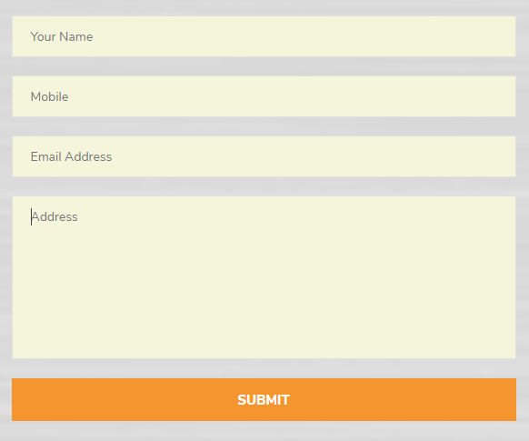

1. **Your name:**

- Don't leave it blank

- Character limit words (6-20)

1. **Mobile:**

- Don't leave it blank

- Only accept numbers and ten digits are required

1. **Email address:**

- Don't leave it blank

- Requires the correct syntax (#@#.com)

|  |  |  |
| --- | --- | --- |
| **List of objectives** | **Status** | |
| **Yes** | **No** |
| Do all text links lead to the appropriate Web site ? | X |  |
| Do all image links lead to the appropriate Web site | X |  |
| Are all the images and links clearly visible on the page ? | X |  |
| Is the Web page opening properly in all the tested Web browsers ? | X |  |
| Is the Web page talking too long to load? |  | X |
| Is the navigation sequences correct through all the Web pages on the site? | X |  |
| Is the JavaScript code working as expected in all click events? | X |  |

|  |  |  |  |  |  |
| --- | --- | --- | --- | --- | --- |
| Series  No | Particulars | Yes | No | NA | Comments |
| 1 | Are all the users able to view the images and links? | X |  |  |  |
| 2 | Have all the views, modules,and controllers been properly intergrated and is the site function as a Single Page Appliacation? | X |  |  |  |
| 3 | Are the GUI content devoid of spelling mistakes? | X |  |  |  |
| 4 | Is the application user-friendly? | X |  |  |  |
| 5 | Is the Web site launching correctly in the browser | X |  |  |  |

|  |  |  |  |  |  |  |  |
| --- | --- | --- | --- | --- | --- | --- | --- |
| **No** | **Member** | **Contents** | **Page Name** | **Activity Plan** | **Date of Preparation of Activity Plan** | | |
| **Planed Start Date** | **Actual Start Date** | **Actual Days** | **Status** |
| 1 | PHUNG THE VIET | 1. Menu bar.  2. Layout of featured products | Home | July 9, 2020 | July16, 2020 | 8 | OK |
| 2 | Create a table with Feedback information | Feedback | July 14, 2020 | July16, 2020 | 2 | OK |
|  | | | | | | | |
| 1 | NGUYEN VAN MINH | 1. Menu bar.  2. Search bar  3. Product layout | Menu | July 9, 2020 | July16, 2020 | 8 | OK |
| 2 | 1. Locate the store.  2. Information of the store | Store Location | July 13, 2020 | July16, 2020 | 3 | OK |
| 3 | 1. Locate the map.  2. Create a table with contact information. | Locations | July 13, 2020 | July16, 2020 | 3 | OK |
| 4 |  |  |  |  |  |  |
|  | | | | | | | |
| 1 | NGUYEN CONG DANH |  | Franchise | July 9, 2020 |  |  | NO |
| 2 |  | Event | July 9, 2020 |  |  | NO |

**Task Sheet**

**TABLE OF CONTENTS**

PAGE 1 Project Cover

PAGE 2 Project Certificate

PAGE 3 Project Information

PAGE 4 Project Definition

PAGE 5 Project Definition

PAGE 6 Customer Requirement Specifications

PAGE 7 Architecture And Design Of The Project

PAGE 8 SitMap

PAGE 9 Screen Shot | Home

PAGE 10 Screen Shot | Home

PAGE 11 Screen Shot | Home

PAGE 12 Screen Shot | Menu

PAGE 13 Screen Shot | Store Location

PAGE 14 Screen Shot | Feedback

PAGE 15 Testing Document

PAGE 16 Final Checklist

PAGE 17 Task Sheet

PAGE 18 Table Of Contents